TECHNICAL PROJECT REPORT

Title of Invention / Project:

**Temperature sensing glass**

Team Members / Inventors:

|  |  |  |  |  |  |
| --- | --- | --- | --- | --- | --- |
| **S. No.** | **Name** | **Department** | **Designation** | **Mobile** | **E-Mail** |
| 1. | Gaurav Agrawal | CSE IBM CC | Student | 8288984324 | [gauravagrawal258@gmail.com](mailto:gauravagrawal258@gmail.com) |
| 2. | Pratham Aggrawal | CSE IBM CC | Student | 7087731914 | [prakashpratham89@gmail.com](mailto:prakashpratham89@gmail.com) |
| 3. | Sanketsaagarkaran | CSE IBM CC | Student | 8603256934 | [sanketsaagar1234@gmail.com](mailto:sanketsaagar1234@gmail.com) |
| 4. |  |  |  |  |  |
| 5. | Khushal Thakur | ECE | Mentor | 9646030764 | [khushal.thakur@cumail.in](mailto:khushal.thakur@cumail.in) |
| 6. | Anshul Sharma | ECE | Mentor | 9478697475 | [anshulsharma.ece@cumail.in](mailto:anshulsharma.ece@cumail.in) |
| 7. | Kiran Jot Singh | ECE | Mentor | 9463909689 | [kiranjotsingh.ece@cumal.in](mailto:kiranjotsingh.ece@cumal.in) |
| 8. | Divneet Singh Kapoor | ECE | Mentor | 9878422653 | [divneet.ece@cumail.in](mailto:divneet.ece@cumail.in) |

***Section – 1 (IPR Related)***

Brief Abstract (500 words):

Working of this Temperature Controlled Lights Project is simple. When temperature is below 25 degree Celsius then BLUE LED remains ON andremains OFF. When temperature is GRETHER 25 degree then output of LM358 remains HIGH andRED remains in ON.

Now when surrounding’s temperature goes beyond 50 Degree Celsius, output voltage of LM35 at pin 2 also goes higher than 0.5 volt or 500mV. Output of LM35 is connected to Pin 3 of Op-amp LM358. And as we have set the reference voltage (voltage at Pin 2 of LM358) to 0.5 volt, so now voltage at Pin 3 (non-inverting input) becomes higher than voltage at Pin 2 (inverting input) and output of opamp LM358 (PIN 1) becomes HIGH. Output of LM358 connected to the base of NPN transistor Q1, so Q1 also becomes ON and Red LED starts glowing. At the same time, base of Transistor Q2 gets ground and Q2 becomes OFF and yellow LED also becomes OFF. So that’s how the circuit detects the temperature limit and indicates by glowing the Red LED.

# Novel/Additional modifications that you can propose to improve upon drawbacks

*(List down the features)*

* Output of LM35 is stable because it easily and instantly give output as temperature is change.
* On changing temperature brightness is alsochange.

# Advantages

(*List down the advantages, if each feature is incorporated)*

* Less expensive
* Good stability

# Block Diagram

(*Functional diagram depicting the flow of information in your system. Do not define exact components, only use generic terms. Must include modifications as well.)*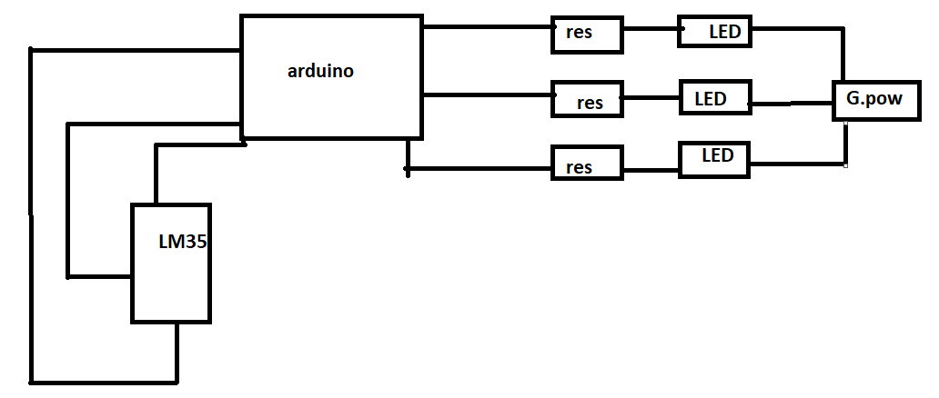

***Section – 2 (Real Project)***

Materials

(*List down the Components, Equipment, etc. actually used in the project*)

Ardiuno

Temperature sensor LM35(1)

10k ohm Resistor (3)

Circuit Diagram

(*Fully functional circuit diagram with exact connections. Can use Fritzing/Proteus*)

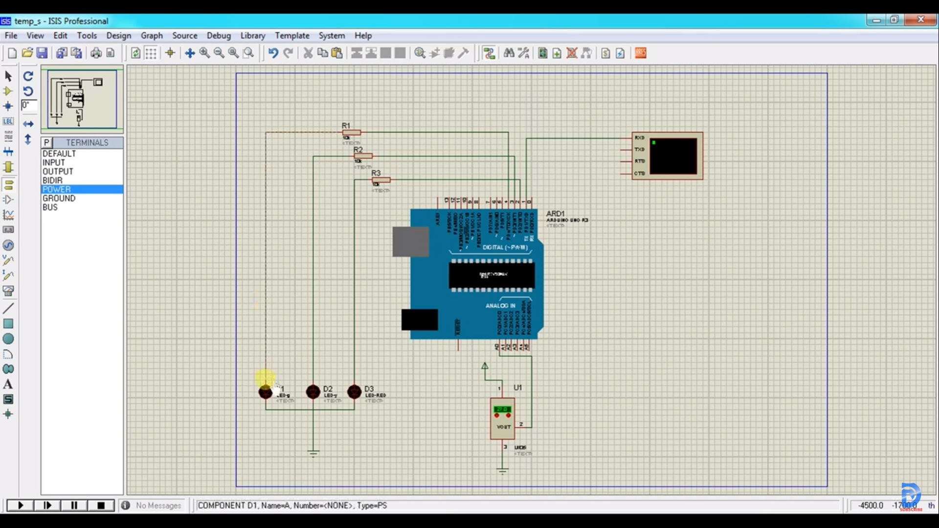

# Steps of Circuit Completion

(*Bifurcate the circuit completion in steps, specify with photographs, leading to final project*)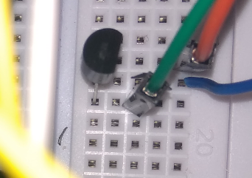

Step 1:Insert LM35

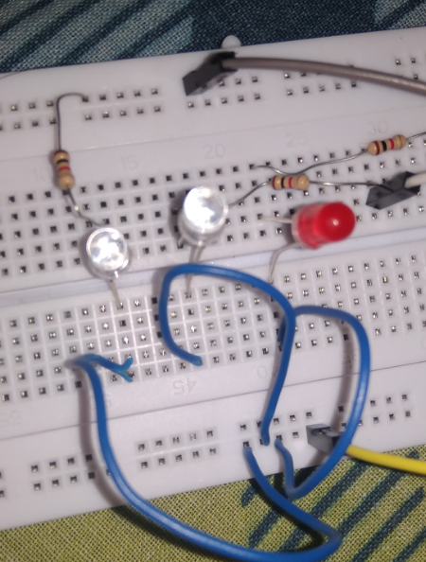

Step 2:Insert LED’s

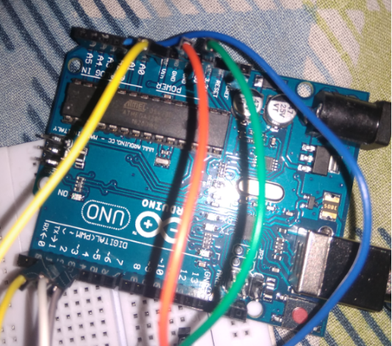

Step 3:Connect with Arduino

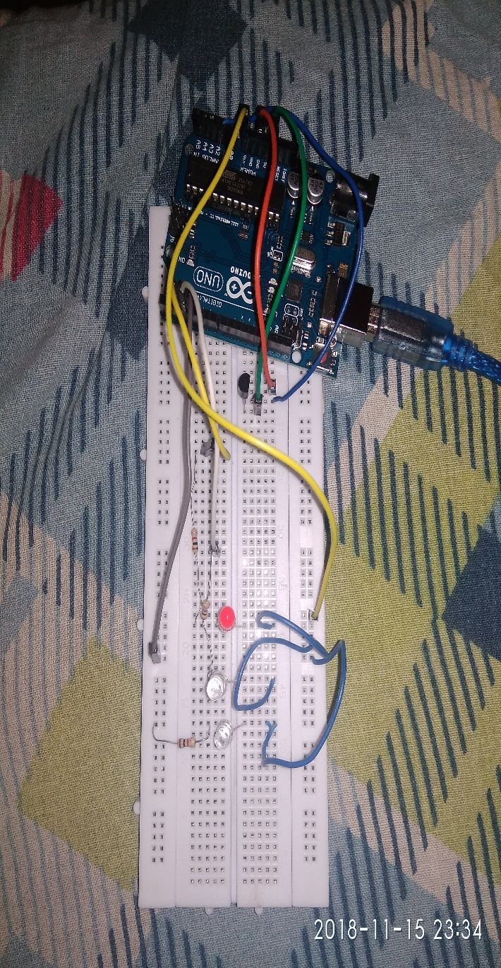Whole circuit

(*Bifurcate the circuit completion in steps, specify with photographs, leading to final project*)

Program Code

(*Link of your Github project*)

No program code